CN Assignment 8

********************************************

Name: Yash Oswal

Div: B Roll no: 38

SRN: 201901226

********************************************

What is DHCP?

The Dynamic Host Configuration Protocol (DHCP) is a network management protocol used on

Internet Protocol (IP) networks, whereby a DHCP server dynamically assigns an IP address and other network configuration parameters to each device on the network, so they can communicate with other IP networks. A DHCP server enables computers to request IP addresses and networking parameters automatically from the Internet service provider (ISP), reducing the need for a network administrator or a user to manually assign IP addresses to all network devices. In the absence of a DHCP server, acomputer or other device on the network needs to be manually assigned an IP address, or to assign itself an APIPA address, the latter of which will not enable it to communicate outside its local subnet.

DHCP Server Installation:

Standard DHCP server implementation available in

various Linux distributions is an Open source version

maintained by ISC ( Internet System Consortium ).

* sudo apt-get install isc-dhcp-server

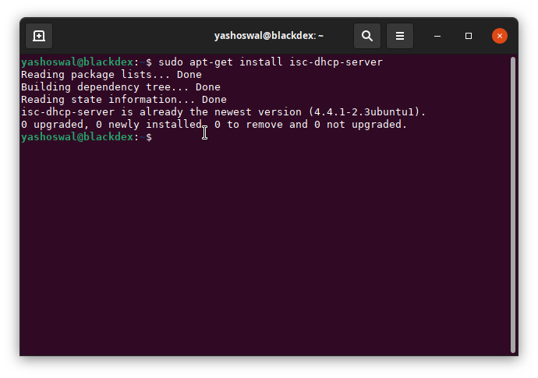

Basic DHCP Configuration

By default, DHCP server configuration does not include any subnets on which DHCP server should lease IP addresses. Therefore, depending on your Linux system you may get the following error message when you attempt to start DHCP with the default dhcpd.conf configuration file.

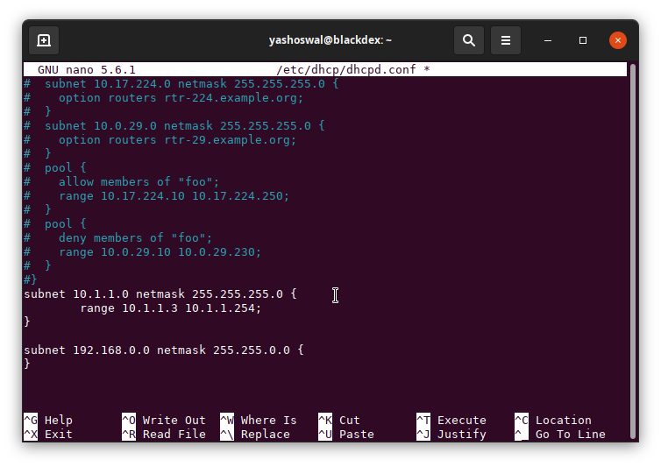

Then restart your dhcp service by

* sudo systemctl restart isc-dhcp-server

This configuration file instructs DHCP server to listen for DHCP client requests on subnet 10.1.1.0 with netmask 255.255.255.0. Furthermore, it will assign IP addresses in range 10.1.1.3 – 10.1.1.254. It also defines an empty definition for subnet with network ID 192.168.0.0

Define DNS Server

Another configuration parameter possible to be set by DHCP server to its client is a definition of DNS server. If you want your clients to use DNS server with an IP address 8.8.8.8 (Google DNS server) and 10.1.1.1 you can do it by including an option domain-name-servers to DHCP’s configuration file.

Set default gateway

DHCP also allows for a client’s gateway configuration. To set any client on the local network to use default gateway 10.1.1.1, add line option routers 10.1.1.1 into dhcpd.conf

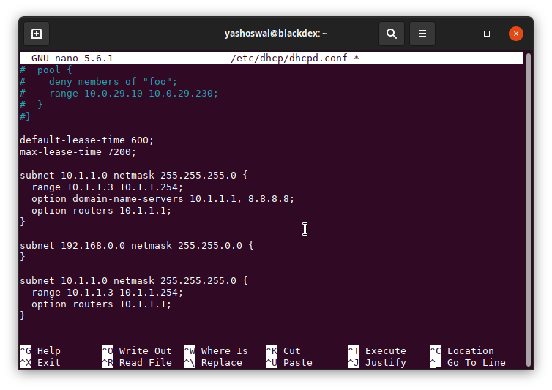

**Other Configuration Options**

To configure your client to use a DHCP on a network interface eth0 on Ubuntu or Debian Linux systems enter the following lines in your /etc/network/interfaces file:

